**Overview:**

In the database, we have 10 tables altogether. Two of them are bridge tables, five of them are about students and the last three are about admins. According to the past emails from SU, we could know that a lot of new increase of COVID-19 cases are caused by gathering and clustering. So, we would like to use this application to reduce the risk of infection as much as possible. And at the same time, it can maintain the normal open of university.

**User stories:**

**Student:**

1. A student can submit their destination, date of their travel so that an admin can judge whether the student is from a high-risk area and determine to change his/her status to red or not. (Duration > 10, status: green=>red)

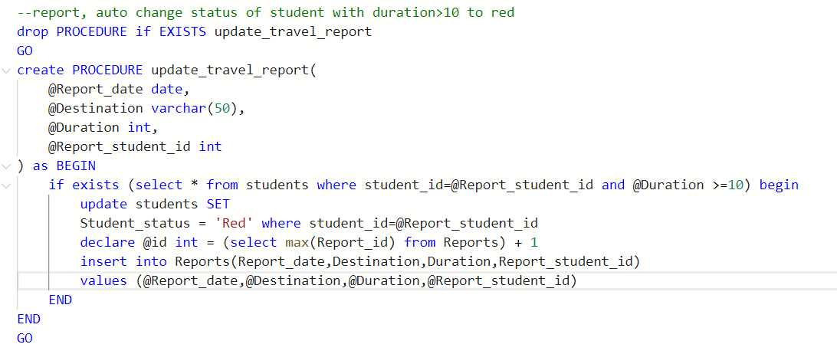

1. A student should submit a request so that he/she can participate in an activity more than 5 people (First, his/her request will be checked automatically by a trigger. If his/her student status is red, his/her request will be refused automatically. And then, admins check the other requests).

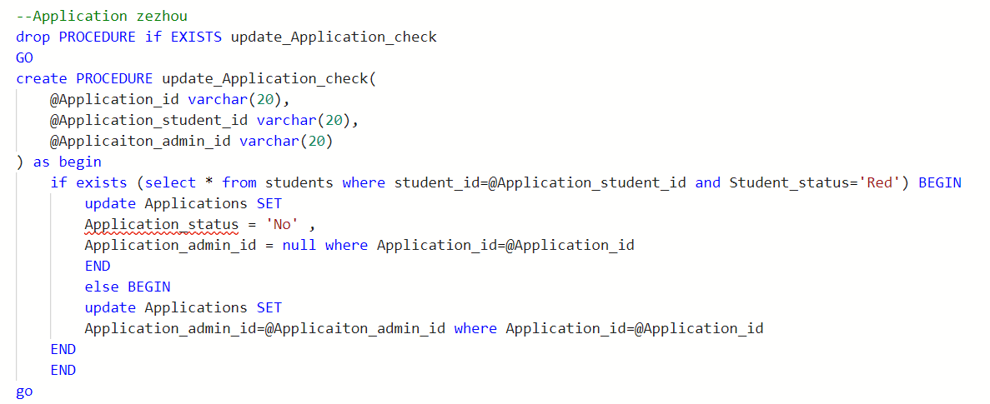

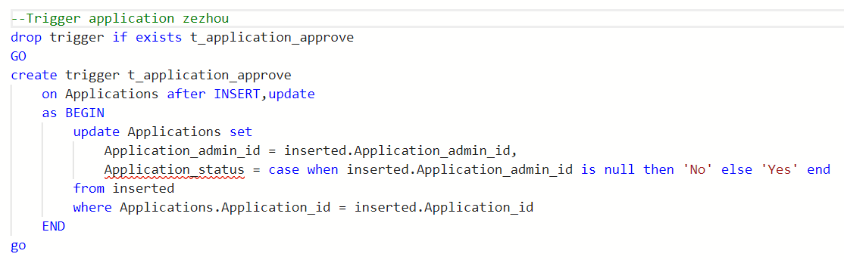

1. A student can check their course to know that their course is online or in-person (i.e. some classes are rotation style, this week is online and next week is in person).

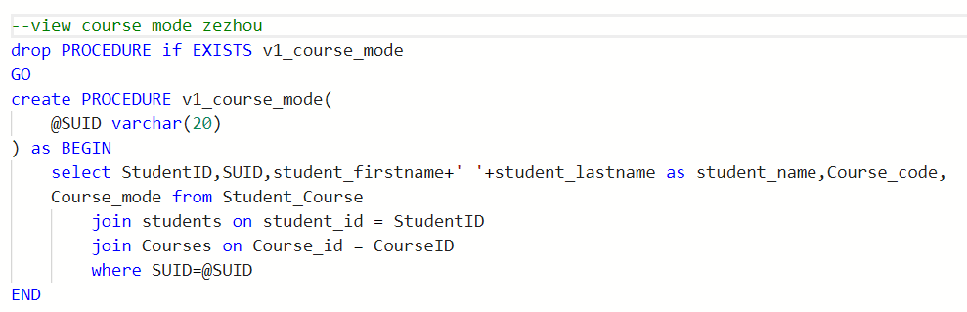

1. A student should report when he/she catches a fever (>=100 °F)in case he/she becomes an asymptomatic carrier.

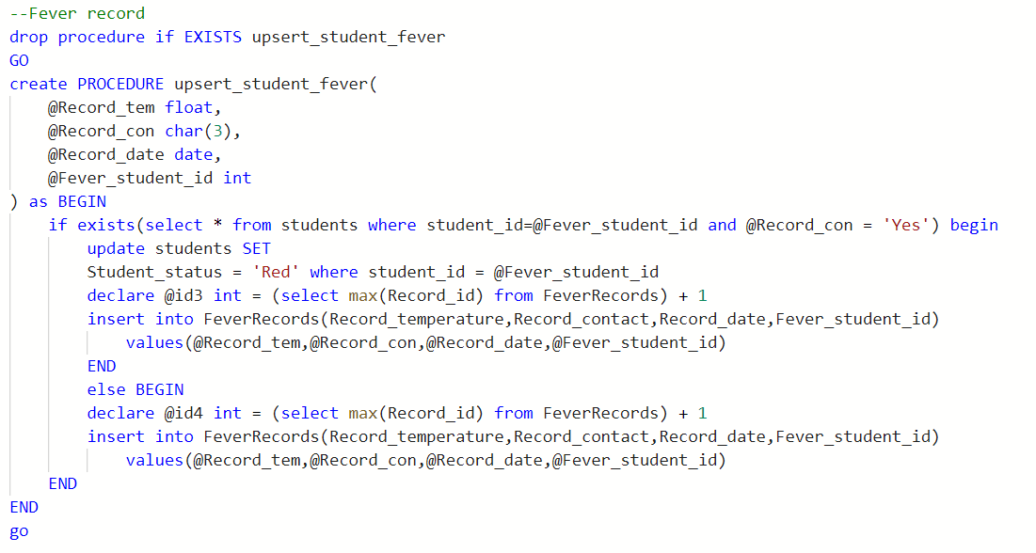

1. A student should report their test result so that an admin can change his/her status to green or red.



1. A student can change their status to green by submitting test table which result is negative.

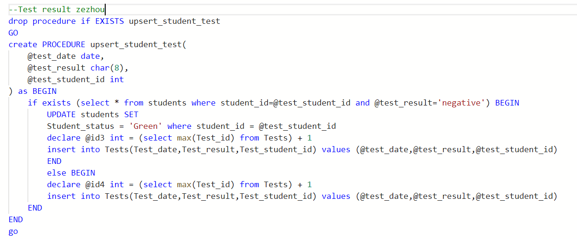

**Admin:**

1. An admin can adjust course mode based on the situation of pandemic and syllabus (rotation style).

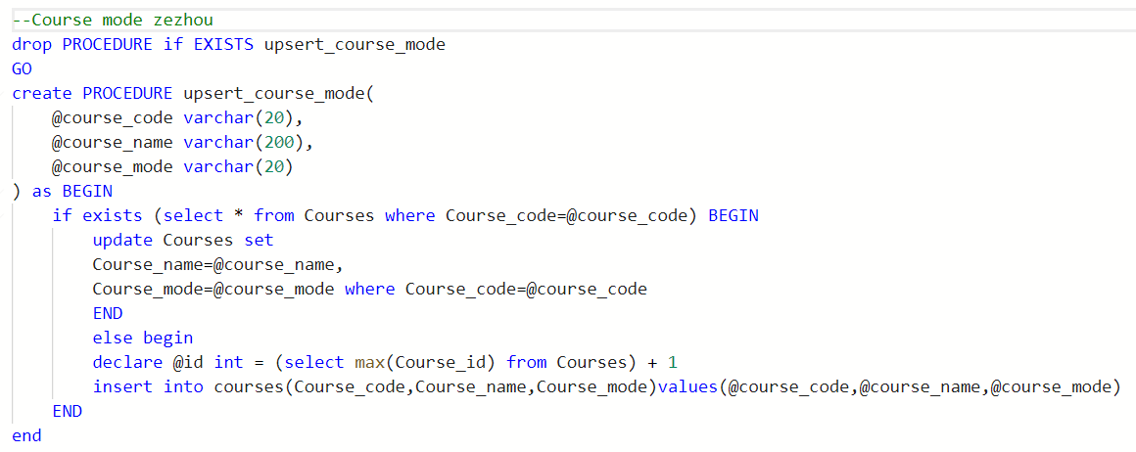

1. An admin can approve or not approve the activity request. (Factor: student status, fever record, travel report and the pandemic situation)

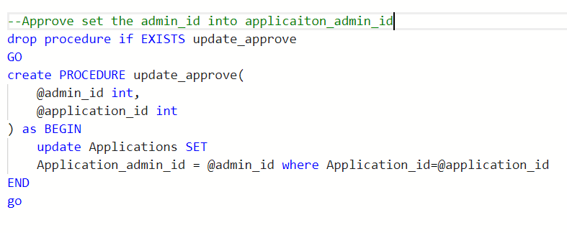

1. An admin can know what he/she should be responsible for from power list.

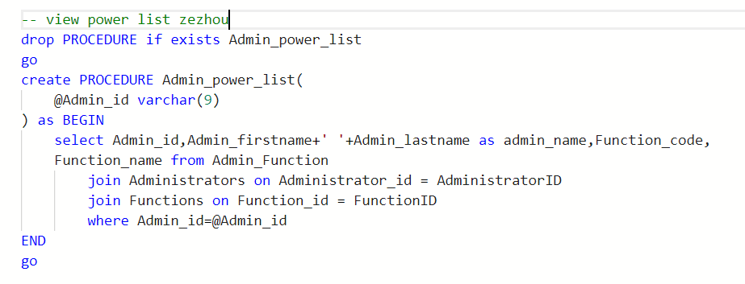

1. An admin can update, delete, create, and retrieve the tables in databases.

